ELEN 460 Lab 8
Optimal Power Flow (OPF), Security Constrained OPF (SCOPF) and Locational Marginal Prices (LMPs) on Small and Medium Sized Systems

Objective:
Gain experience and insights on the use of optimal power flow (OPF), security constrained OPF (SCOPF) and locational marginal prices (LMPs) on both a 37 bus system and a 2000 bus system. Observe the effects as the system load and generation is varied.

Background on 37 Bus APL System
As was the case with the previous lab, we’ll be working with the 37 bus system modeling the fictional Aggieland Power and Light (APL) grid. However, this system has been slightly modified from the lab 7 system, mostly with some enhancements in transmission line and transformer limits to better improve its SCOPF performance. For convenience the generators have been modeled with linear cost functions (that is, a single cost per MWh over their entire MW range). The oneline for this system is shown in Figure 1, including a contour of the bus LMPs. Note that the oneline includes a table that shows selected generator information (current MW, its linear cost value, a cost multiplier, the LMP, and the generator’s profit). For this lab we’ll be assuming that the AGL system has sold off its generation, so there are now ten separate entities, each owning one generator, trying to maximize their individual profits in an LMP market (as discussed in class). All the generators submit offers to the LMP market, but for simplicity we’ll assume that they are just submitting a single $/MWh offer for any or all of their generation capacity.

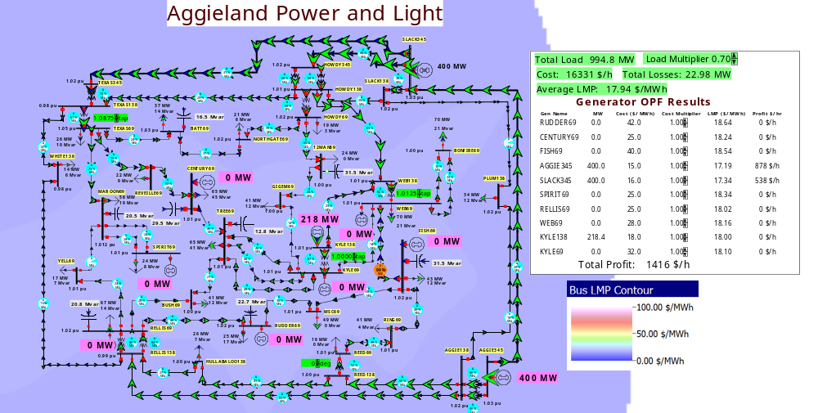

Figure 1: 37 Bus APL System

Procedure for OPF on the APL System
1. Start PowerWorld Simulator. Open the Lab8_AGLOPF case. The system has also been setup to automatically do an OPF, changing the output for all ten generators. Also, the oneline again has a button to allow you to easily scale the load in 5% increments of the APL all time system peak load. Initially we’ll be starting at 70% of the peak load.

2. Select Tools, Play to start the simulation. Note that now it is doing an OPF, as opposed just a power flow. Record the initial Total Load, Hourly Cost, Losses, Average LMP, and the total generator profit
3 Click on the Load Multiplier up arrow (now in the box to the left of the oneline) to increase the load by 5% (of the system peak) to 0.75. Again record the Total Load, Hourly Cost, Losses, Average LMP, and the total generator profit.
4. Repeat Step 3, going up until the Load Multiplier is 1.0. As you do this, at one load multiplier value (of your choice), verify the profit for one generator (again of your choice, but it must be a generator with a non-zero MW output); include this calculation in your report. Note, because of rounding with the display values, getting with $10 is close enough.
5. Decrease the Load Multiplier to 0.9. Up to this point in the lab every generator was offering their generation at marginal cost into the LMP market. In this step you will explore how the profit for the Kyle138 generator would change if they increased their offer. The easiest way to do this is to change the “Cost Multiplier” field, which scales their offer based on their marginal cost. For example, if a generator’s marginal cost is $20/MWh and their Cost Multiplier is changed to 1.5, this is equivalent to a $30/MWh offer. Future Aggies will be able to do this using arrows next to the field on the oneline, but these do not work in the current WEB 115 lab version. Rather, right-click on the KYLE138 cost multiplier field, select Generator Dialog, and go to the Costs, Bid Scale/Shift page. You can change the value from this page using the arrows, but you must click Save to your changes to be reflected in the OPF. However, you do not need to close the dialog between changes. This is shown in Figure 2. Try various values between 1.0 and 3.0 to try to maximize your profit. Record the value that gives you the maximum profit, save an LMP contour to include in your report, and in your report document the strategy you used to achieve this value. Do you think the variation in your profit with respect to the Cost Multiplier could have multiple local maximums?

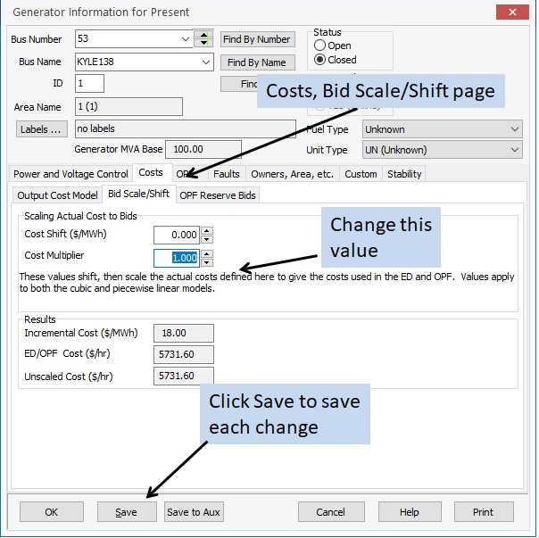
Figure 2: Generator Costs, Bid Scale/Shift Page

Procedure for SCOPF on the APL System
1. In PowerWorld Simulator open the Lab8_AGLSCOPF case. This is the same as the AGL OPF case, except it no longer automatically does an OPF, but rather just a power flow. Currently PowerWorld does not allow for automatic SCOPF solutions, so you’ll need to do each SCOPF solution manually. As before, we’ll be starting at 70% of the peak load.

2. Perform an SCOPF solution at this load level. To do this, select Add Ons, SCOPF to display the SCOPF form. Select the Run Full Security Constrained OPF to perform an SCOPF solution. If desired you can keep this form open. From the oneline record the initial Total Load, Hourly Cost, Losses, and Average LMP. Also, after the SCOPF solution look at the Contingency Violations page of the SCOPF from and record the number of contingency constraints with non-zero marginal costs. An example of this is shown in Figure 3. Because of tolerances in the solution, the marginal costs might change slightly if you were to repeat a solution with the same load scalar.

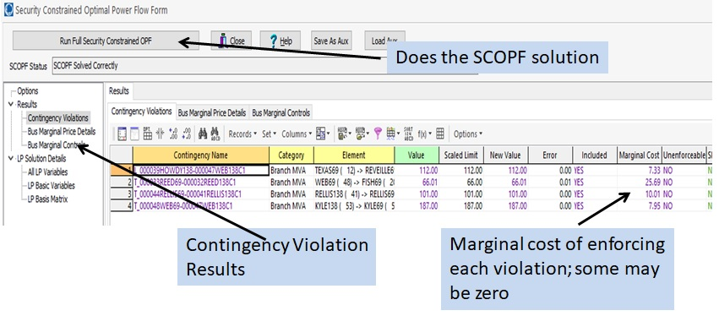
Figure 3: SCOPF Form
3. Repeat steps 2, except sequentially increase the Load Multiplier in 0.1 increments up to 1.0. In your report you will be comparing the recorded cost and average LMP values between the OPF and SCOPF solutions.

Background on the 2000 Bus TSGC System
This is the same Texas Synthetic Grid Company (TSGC) 2000 bus system you used in Lab 7, though the operating conditions are different and you are now working for the TSGC ISO. It is spring, a number of generators are out of service for maintenance and North Texas has just been hit by severe tornado outbreak. Thankfully no one was injured, but the TSGC 500 kV system was hit hard, with six transmission lines with towers down and now out of service. Repairs will take weeks, minimum. Your boss asks you do preliminary study looking at whether there are any loading conditions that could cause problems. Since this is longer term study, you don’t know specifically what load levels to study. And with spring weather in Texas, the load could be almost anything.

To do your study, you’ve got the TSGC system divided into seven areas, and you can scale the load in each region independently. Because this is a longer termer study doing a DC OPF is fine. You decide that a good metric for a bad operating point would be one in which there are high bus LMPs. You’ve saved the starting point, with the load in each region at 80% of peak, as PowerWorld case Lab8_TSGC_DCOPF. You’ve also added a color contour of the bus LMPs. This is shown in Figure 4.

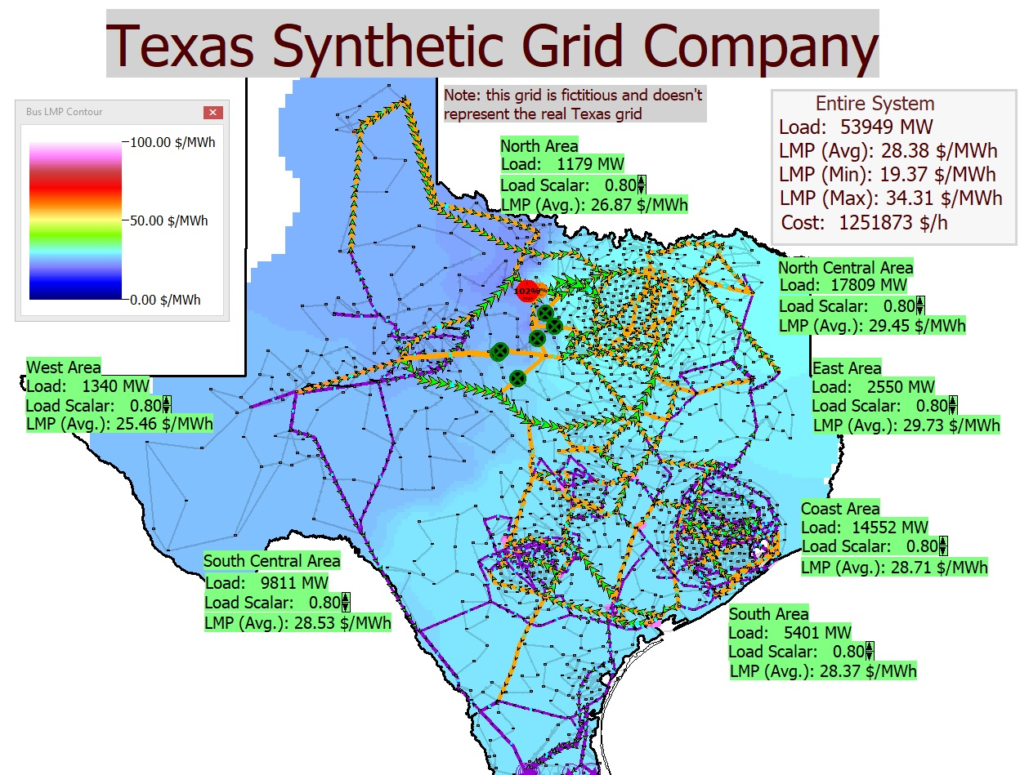
Figure 4: TSGC DC OPF System

Procedure for TSGC DC OPF and SCOPF
      - Open up case Lab8_TSGC_DCOPF. Select Tools, Play to start the simulation. This is now again doing an OPF.
- Change the load in the different areas using the Load Scalar arrows. Go between 0.80 and 1.05 in 0.05 increments to try to find the worst case conditions. With seven areas and load scalar six options per area (0.8, 0.85, 0.9, 0.95, 1.0, 1.05) you obviously cannot check all 6⁷ = 279,936 possibilities. Try various possibilities, and in your report describe your search strategy. The LMP contour and the area LMP averages shown on the oneline will give you a feel for the high LMP situations. To see the specific values, use Case Information, Buses, which provides a sorted list of the bus LMPs (in the column labeled MW Marg. Cost).
- Save an oneline image of the worst condition that you found. Describe the metric you used for worst (recognizing that different students may use different metrics). Note the highest LMP.
- Now, as an Aggie you decide to go the extra mile and consider some emergency load shed plans to address the worst case condition you found in the previous step. Of course, load shedding is always a last resort, something that would only be used if the worst case condition you studied actually occurred and then it would be considered with an ac solution. But still it can be good to be prepared! Starting from your worst case loading condition, open the Case Information, Load display to see a list of the loads, sorted by the highest LMP. Starting with the load with the highest LMP, record its bus number, load MW value and bus LMP. Then double click on its status field to open it. With the OPF running, the display will immediately refresh as it resorts – so the load you just opened may vanish. Try at least a few and record them for inclusion in your report. At any point you can see the loads you opened by sorting on the status field (in PowerWorld you can sort a column by double clicking on its column header, doing it a second time reverses the sort order).
- Finally, you decide it would be good to at least try a DC SCOPF. The Lab8_TSGC_DCOPF case has 340 contingencies associated with high voltage transmission line and transformer outages. While normally you would run many more for N-1, given the lab time constraints this is sufficient. So again open up case Lab8_TSGC_DCOPF. Then, without starting the simulation (which would do an OPF and over write your results), select Add Ons, SCOPF to display the SCOPF form. Select the Run Full Security Constrained OPF to perform an SCOPF solution. Save the total solution time (which is shown on the SCOPF form in the SCOPF Results Summary section). Contour the LMPs and save an image for your report.
- Change the load scalar in one area (of your choice) to 1.0, and rerun the SCOPF, again saving an image for your report. In your report comment on why you choose this area, and how the change affected your results.

Report:
For both the APL and TSGC systems, provide a summary of the procedures you followed and the results you have obtained. For the AGL system provide graph showing how the hourly cost varied with loading for the OPF and SCOPF solutions, and another graph showing how the average LMPs varied with loading for the OPF and SCOPF solutions. Explain why the costs would be different, and which one you expected would be lower. You might also want to include a graph discussing your KYLE138 profit maximization approach. Include a discussion of your profit maximization strategy and your LMP contour image.
For the TSGC include a discussion of the heuristic strategy you used to get the worst case (from an LMP perspective at least) situation. Then comment how the LMPs were affected by your proposed emergency load shedding.

